SCHOOL OF COMPUTER SCIENCE AND ARTIFICIAL INTELLIGENCE |  |  |  |  | DEPARTMENT OF COMPUTER SCIENCE ENGINEERING
Program Name: B. Tech |  |  |  | Assignment Type: Lab |  |  | Academic Year:2025-2026
Course Coordinator Name |  |  |  | Venkataramana Veeramsetty
Instructor(s) Name |  |  |  | Dr. V. Venkataramana (Co-Ordinator)  Dr. T. Sampath Kumar  Dr. Pramoda Patro  Dr. Brij Kishor Tiwari  Dr.J.Ravichander  Dr. Mohammand Ali Shaik  Dr. Anirodh Kumar  Mr. S.Naresh Kumar  Dr. RAJESH VELPULA  Mr. Kundhan Kumar  Ms. Ch.Rajitha  Mr. M Prakash  Mr. B.Raju  Intern 1 (Dharma teja)  Intern 2 (Sai Prasad)  Intern 3 (Sowmya)  NS_2 ( Mounika)
Course Code |  |  | 24CS002PC215 | Course Title |  | AI Assisted Coding
Year/Sem |  |  | II/I | Regulation |  | R24
Date and Day  of Assignment |  |  | Week2 - Monday | Time(s)
Duration |  |  | 2 Hours | Applicable to  Batches
Assignment Number:4.1(Present assignment number)/24(Total number of assignments)
 | Q.No. | Question |  |  |  |  |  | Expected Time  to complete
 | 1 | Lab 4: Advanced Prompt Engineering – Zero-shot, One-shot, and Few-shot Techniques  Lab Objectives:  - To explore and apply different levels of prompt examples in AI-assisted code generation.  - To understand how zero-shot, one-shot, and few-shot prompting affect AI output quality.  - To evaluate the impact of context richness and example quantity on AI performance.  - To build awareness of prompt strategy effectiveness for different problem types.  Lab Outcomes (LOs):  After completing this lab, students will be able to:  - Use zero-shot prompting to instruct AI with minimal context.  - Use one-shot prompting with a single example to guide AI code generation.  - Apply few-shot prompting using multiple examples to improve AI responses.  - Compare AI outputs across the three prompting strategies.  Task #1 – Zero-Shot Prompting with Conditional Validation  Objective  Use zero-shot prompting to instruct an AI tool to generate a function that validates an Indian mobile number.  Requirements  - The function must ensure the mobile number:  - Starts with 6, 7, 8, or 9  - Contains exactly 10 digits  Prompt:Generate a function in Python that validates an Indian mobile number. The function must check that the number starts with 6, 7, 8, or 9 and contains exactly 10 digits for a number given by user  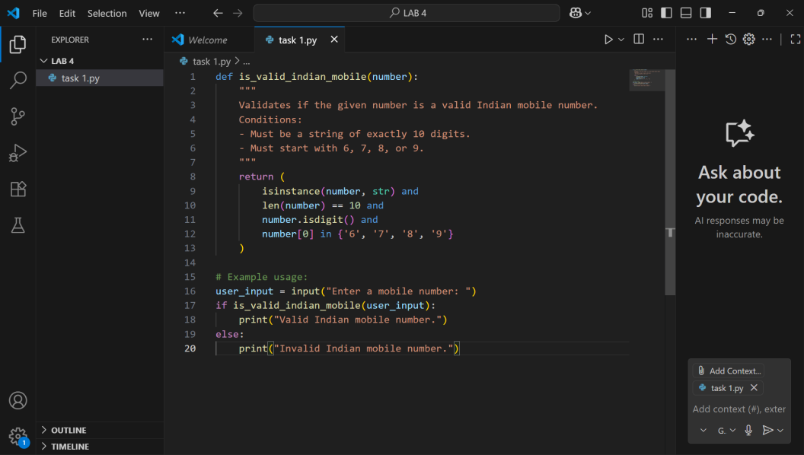  Expected Output  - A valid Python function that performs all required validations without using any input-output examples in the prompt.  - 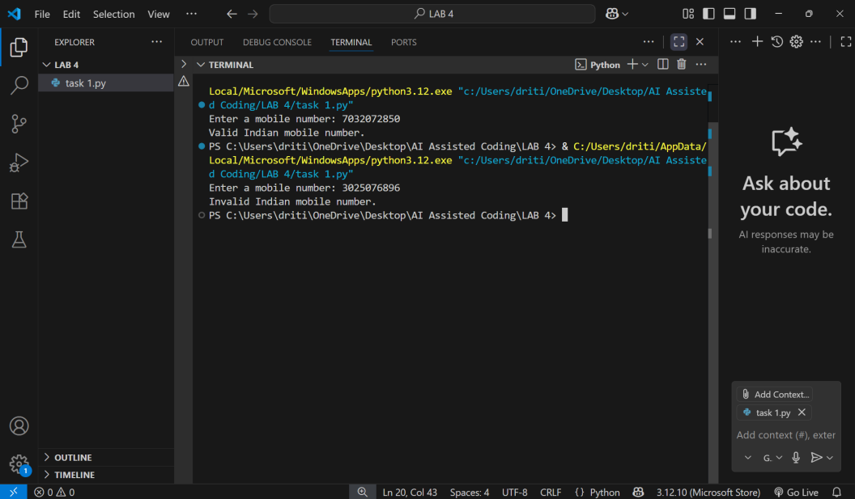  Task #2 – One-Shot Prompting with Edge Case Handling  Objective  Use one-shot prompting to generate a Python function that calculates the factorial of a number.  Requirements  - Provide one sample input-output pair in the prompt to guide the AI.  - The function should handle:  - 0! correctly  - Negative input by returning an appropriate message  Prompt: Generate a Python function that calculates the factorial of a number. The function should handle 0! correctly and return an appropriate message if the input is negative. For example, if the input is 5, the output should be 120  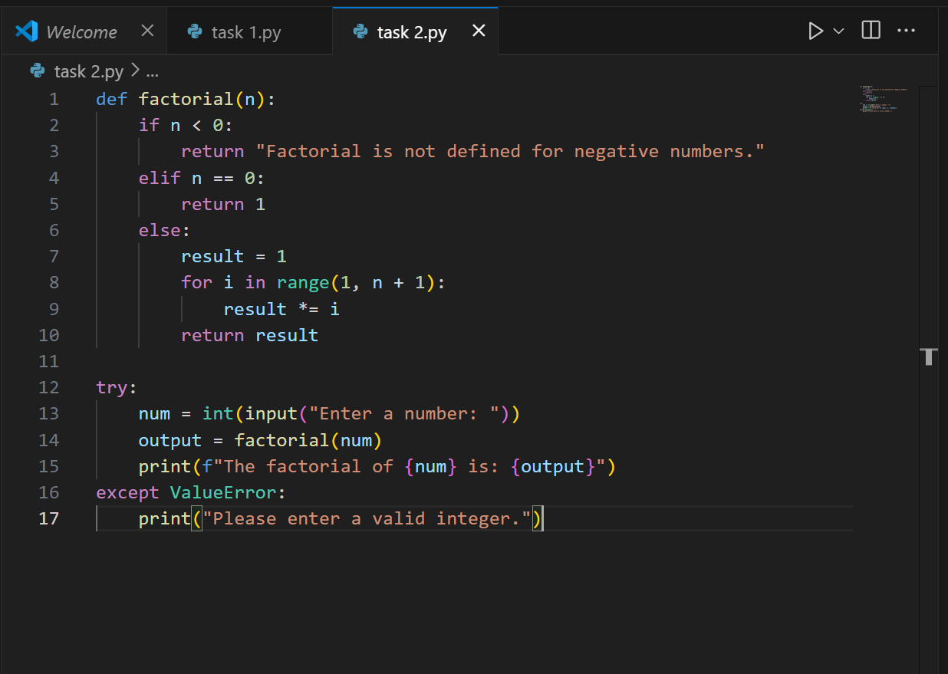  Expected Output  - A Python function with correct factorial logic and edge case handling, generated from a single example.  - 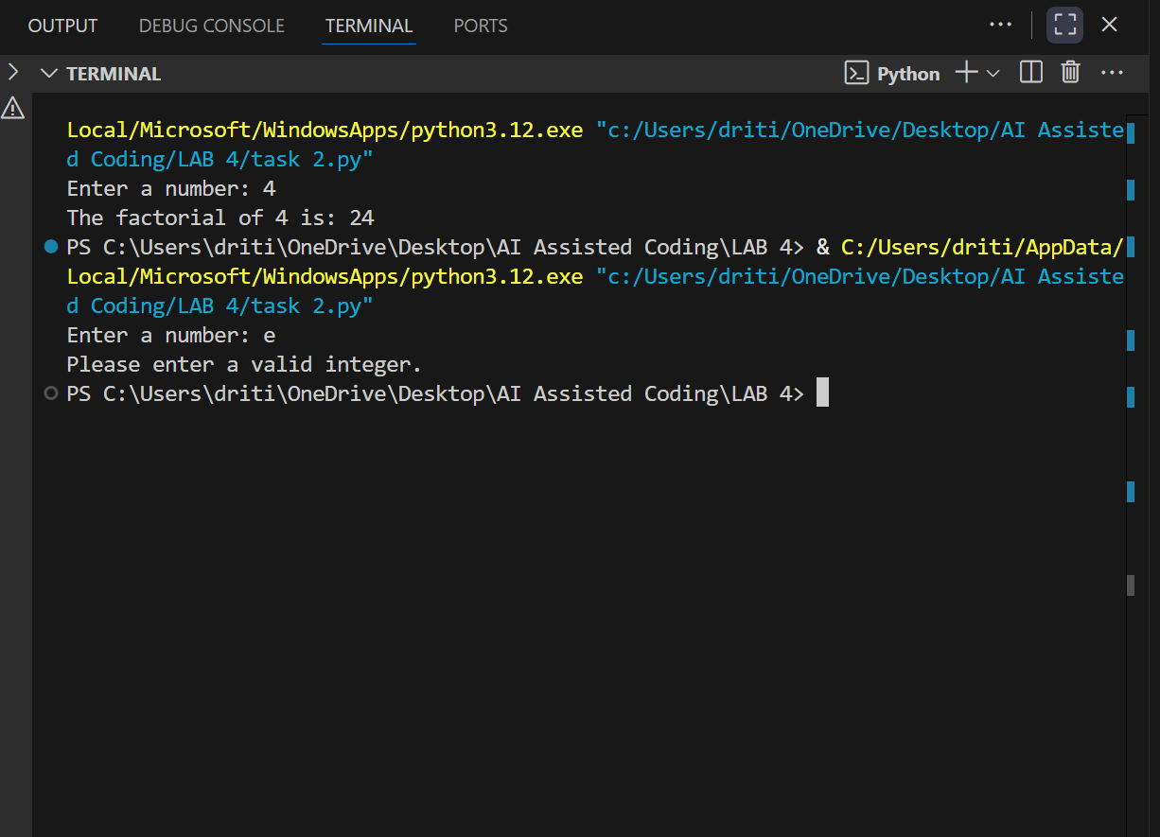  Task #3 – Few-Shot Prompting for Nested Dictionary Extraction  Objective  Use few-shot prompting (2–3 examples) to instruct the AI to create a function that parses a nested dictionary representing student information.  Requirements  - The function should extract and return:  - Full Name  - Branch  - SGPA  Prompt : Create a Python function that parses a nested dictionary representing student information. The function should extract and return the student’s full name, branch, and SGPA.  Example 1:  Input:  student = {  "personal": {"first_name": "Amit", "last_name": "Sharma"},  "academic": {"branch": "CSE", "sgpa": 8.7}}  Output:  Full Name: Amit Sharma, Branch: CSE, SGPA: 8.7  Example 2:  Input:  student = {  "personal": {"first_name": "Riya", "last_name": "Verma"},  "academic": {"branch": "ECE", "sgpa": 9.2}  }  Output:  Full Name: Riya Verma, Branch: ECE, SGPA: 9.2  Now, generate the function that works for such inputs.  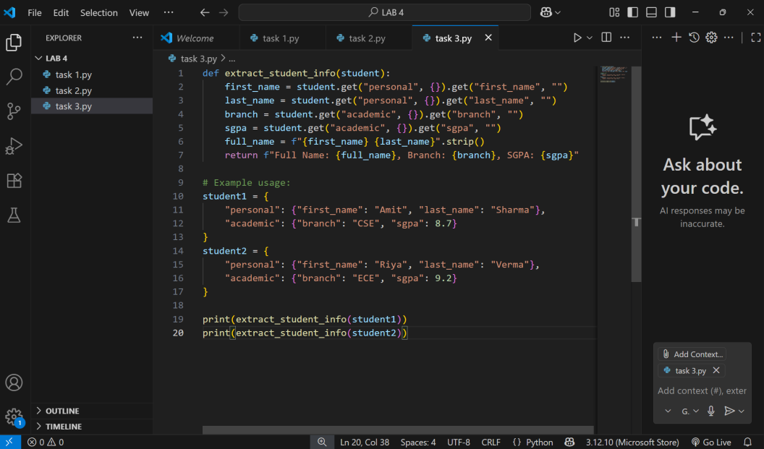  Expected Output  - A reusable Python function that correctly navigates and extracts values from nested dictionaries based on the provided examples.  - 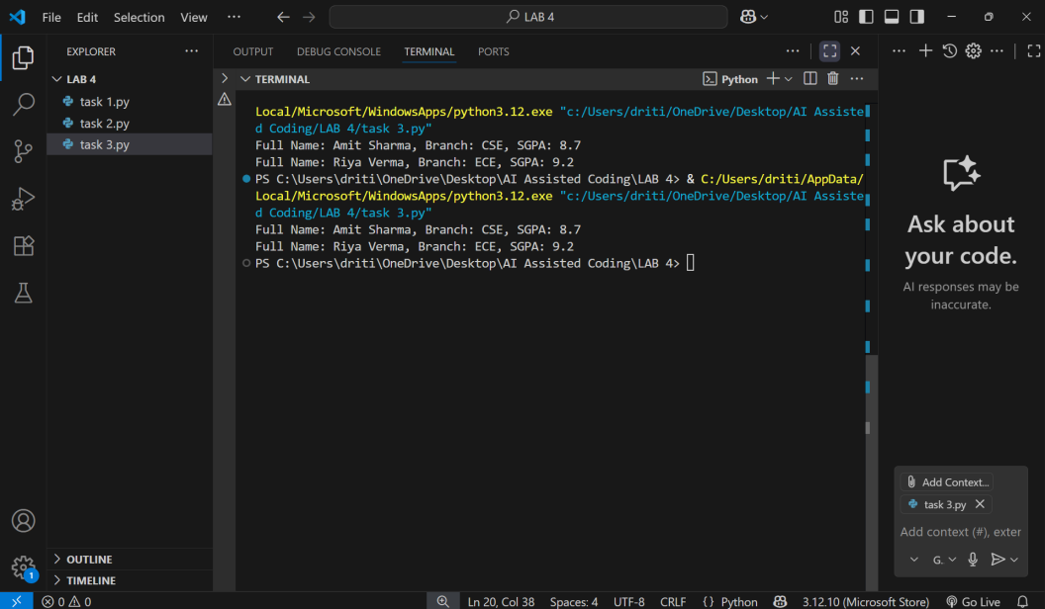  Task #4 – Comparing Prompting Styles for File Analysis  Objective  Experiment with zero-shot, one-shot, and few-shot prompting to generate functions for CSV file analysis.  Requirements  - Each generated function should:  - Read a .csv file  - Return the total number of rows  - Count the number of empty rows  - Count the number of words across the file  Prompt 1:Generate a Python function that reads a .csv file and performs the following tasks:  1. Return the total number of rows  2. Count the number of empty rows  3. Count the total number of words across the file  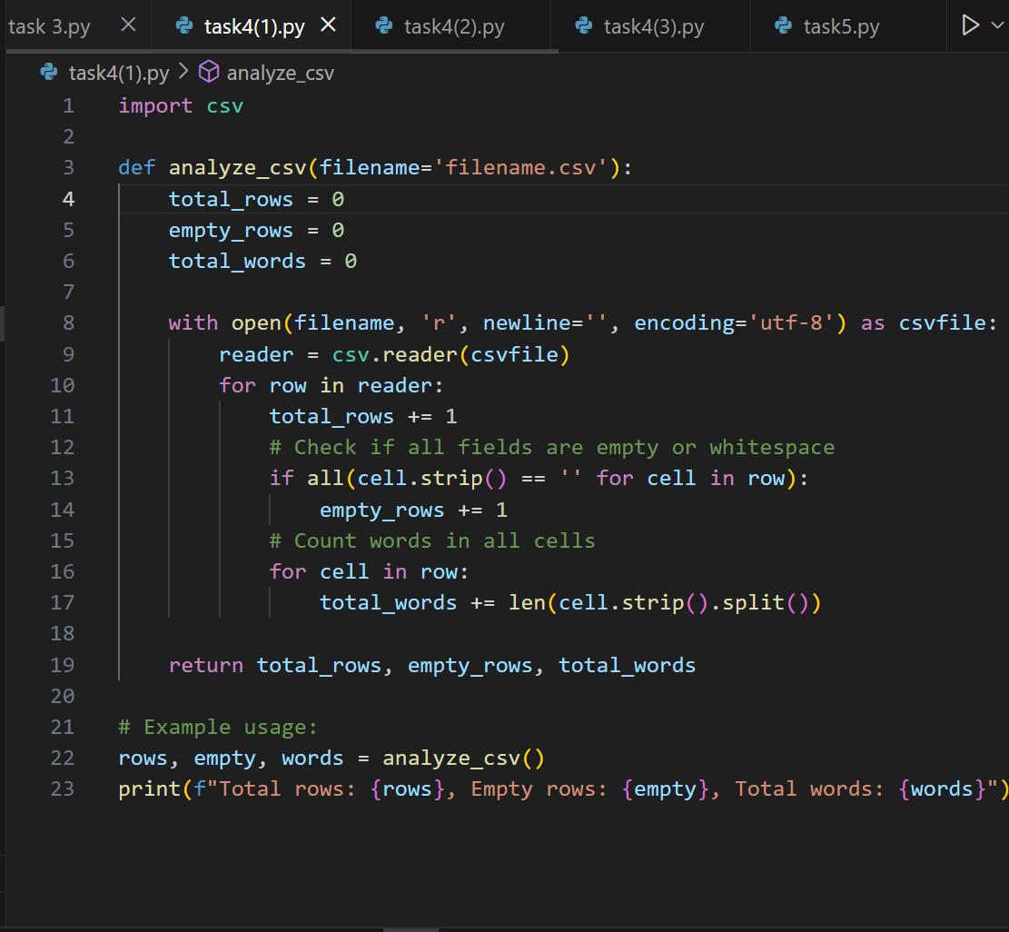  Prompt 2:Generate a Python function that reads a .csv file and performs the following tasks:  1. Return the total number of rows  2. Count the number of empty rows  3. Count the total number of words across the file  Example:  Suppose the CSV file has the following content:  Name, Age  Amit, 21  ,  Riya, 22  Expected Output:  Total Rows: 4  Empty Rows: 1  Total Words: 5  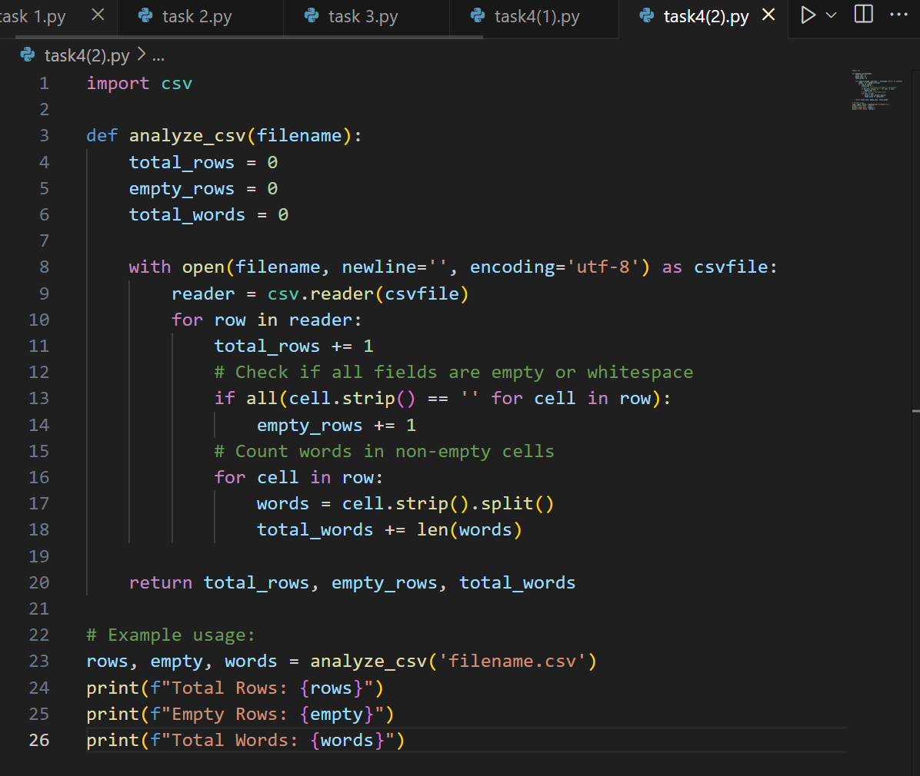  Prompt 3:Generate a Python function that reads a .csv file and performs the following tasks:  1. Return the total number of rows  2. Count the number of empty rows  3. Count the total number of words across the file  Example 1:  CSV Content:  Name, Marks  Amit, 85  Riya, 90  Expected Output:  Total Rows: 3  Empty Rows: 0  Total Words: 4  Example 2:  CSV Content:  ID, Branch  101, CSE  102, ECE  ,  103, ME  Expected Output:  Total Rows: 5  Empty Rows: 1  Total Words: 6  Now, generate a general Python function that works for any CSV file.  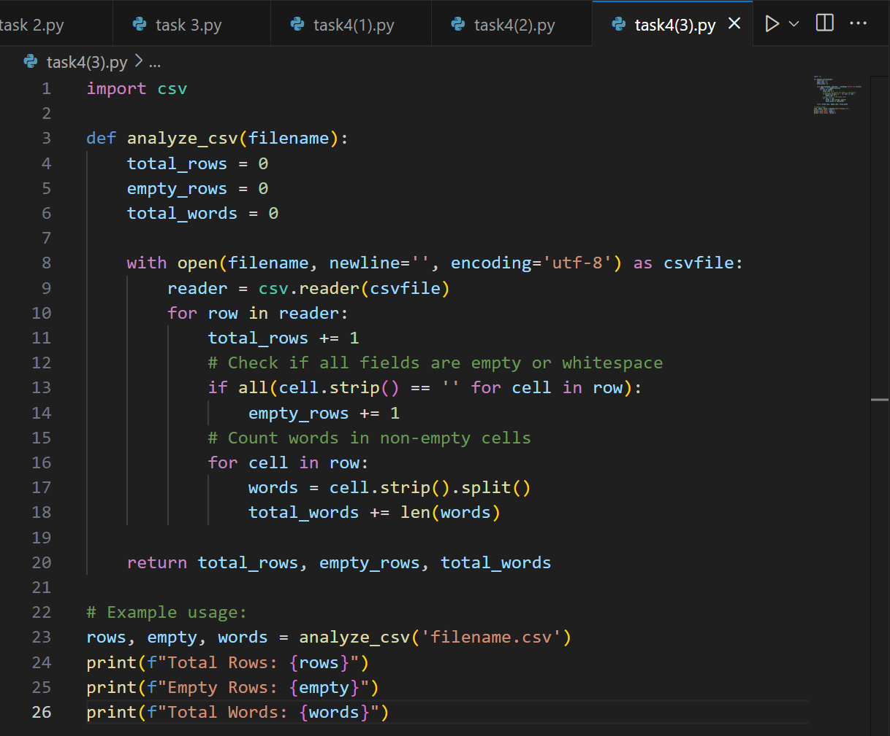  Expected Output  - Working Python functions for each prompting style, with a brief reflection comparing their accuracy, clarity, and efficiency.  Output 1: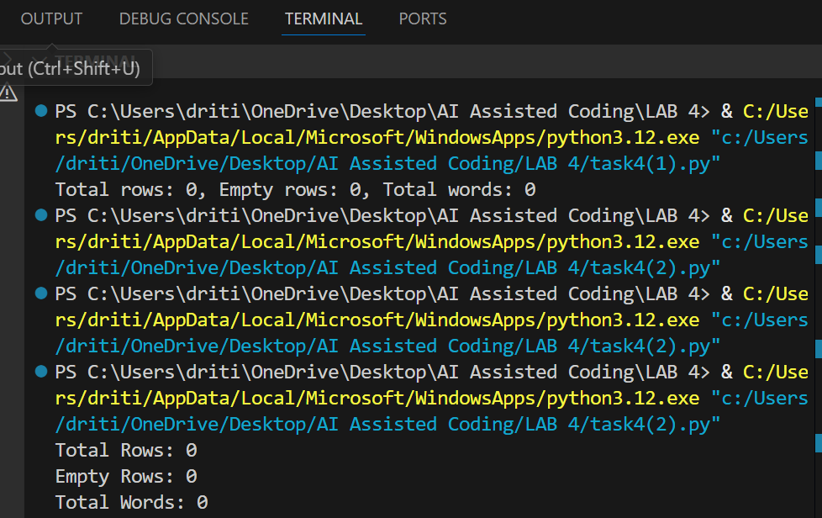  Output 2:  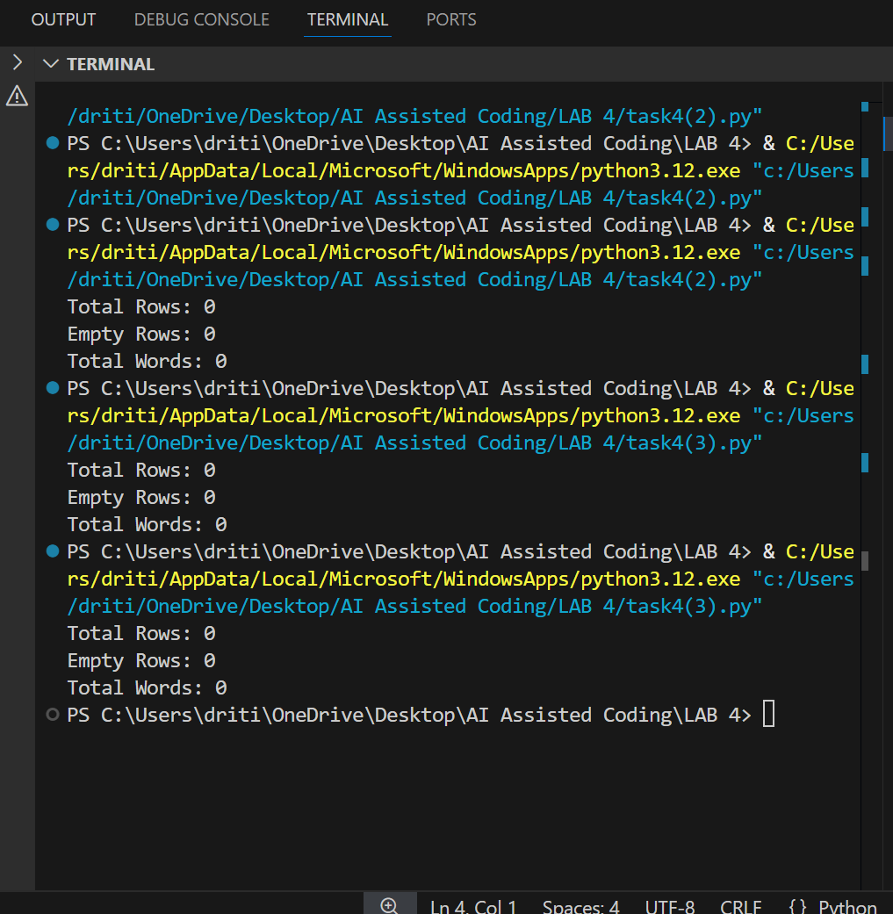  Output 3:    Report on three prompts:  1.In the zero-shot approach, only a direct instruction was provided without any examples. The function was generated successfully but needed minor adjustments and was less reliable compared to other methods.  2.In the one-shot approach, the instruction was supported with one input–output example. This improved the accuracy of the generated function, which was better aligned with the task requirements and handled row and word counts more effectively.  3In the few-shot approach, the instruction was accompanied by two input–output examples. This method produced the most accurate and robust function. It was able to handle variations in CSV structure and empty rows more effectively than the zero-shot and one-shot approaches.  4.In conclusion, zero-shot prompting is quick but less dependable, one-shot prompting improves accuracy with a single example, and few-shot prompting is the most reliable and generalizable method for generating correct and versatile functions.  Task #5 – Few-Shot Prompting for Text Processing and Word Frequency  Objective  Use few-shot prompting (with at least 3 examples) to generate a Python function that processes text and analyzes word frequency.  Requirements  The function must:  - Accept a paragraph as input  - Convert all text to lowercase  - Remove punctuation  - Return the most frequently used word  Prompt : Create a Python function that processes text and analyzes word frequency.  The function must:  1. Accept a paragraph as input  2. Convert all text to lowercase  3. Remove punctuation  4. Return the most frequently used word  Example 1:  Input: "Hello world! Hello everyone."  Output: "hello"  Example 2:  Input: "Data science is fun. Science requires data."  Output: "data"  Example 3:  Input: "AI, AI, and more AI is the future."  Output: "ai"  Now, generate the Python function that works for such inputs.  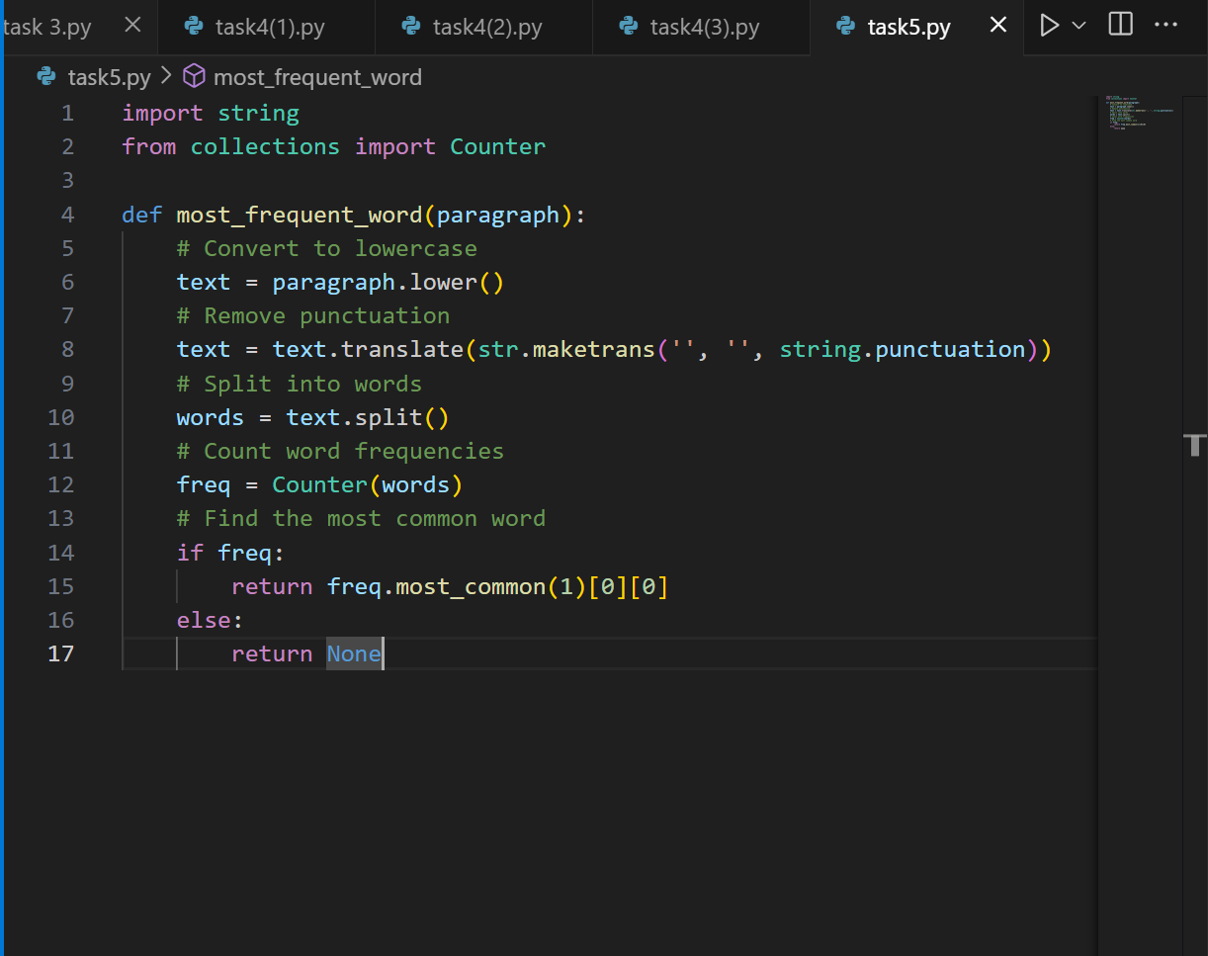  Expected Output  - A functional Python script that performs text cleaning, tokenization, and returns the most common word using only the examples provided in the prompt  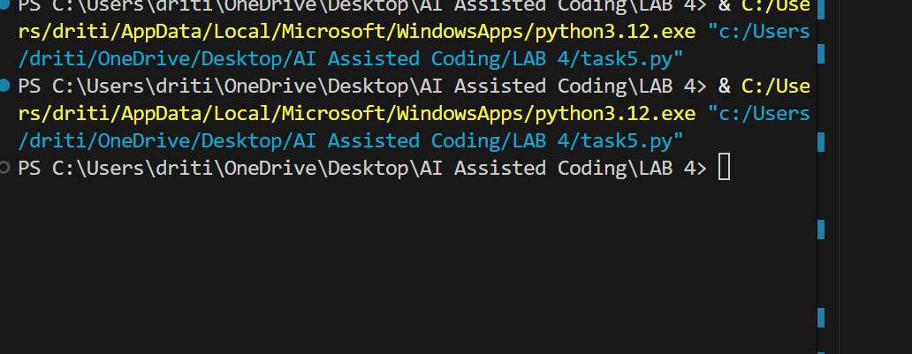  Note: Report should be submitted a word document for all tasks in a single document with prompts, comments & code explanation, and output and if required, screenshots  Evaluation Criteria:  Criteria Max Marks  Zero Shot (Task #1) 0.5  One Shot (Task#2) 0.5  Few Shot (Task#3, Task#4 & Task #5) 1.5  Total 2.5 Marks |  |  |  |  |  | Week2 - Monday

